**ECE0202: Embedded Systems and Interfacing**

**Lab 5: Stepper Motor Control (in assembly)**

**Due April 3rd 11:59 pm**

**Objectives**

* **Use full stepping to control the speed and position of a stepper motor**
* **Generate pulse waveforms to control a stepper motor**
* **Use Darlington transistor arrays to perform high-current driving with extremely low input current**

**Pre-Lab Reading**

* **Read Textbook Chapter 16: Stepper Motors**
* **Watch the following video tutorials (credit to pcbheaven):**
  + http://www.youtube.com/watch?v=MHdz3c6KLrg
  + http://www.youtube.com/watch?v=t-3VnLadIbc
* **Answer the pre-lab questions**

**Deliverables**

* **(40 points) Basic requirement: Code that operates a simulated “windshield wiper” on the stepper motor.** 
  + **When the on-board button is held down, the stepper motor will rotate approximately 145 $°$ counterclockwise, then 145 $°$ clockwise, then repeat over and over. When the button is released, the “windshield wiper” should finish its current routine and stop when it returns to 0 $°$.**
* **(10 points) Answers to the pre-lab questions. Indicate how each group member participates and contributes to the lab at the end of the lab report.**
* **(50 points) A demonstration of the operational circuit to an instructor or TA.**
* **10 points extra credit: Display the degree and turning direction of the motor in real time on the Tera Term.**

**Please submit your code as *.s files**

Based on a lab from ECE271 at the University of Maine by Yifeng Zhu.

**Stepper Motor Overview**

|  |  |  |  |  |
| --- | --- | --- | --- | --- |
| USPRO® 5v 4-phase 5-wire Stepper Motor (28byj-48-5v) with Uln2003 Stepper Motor Driver Board for Arduino | | http://www.modmypi.com/image/cache/data/rpi-products/hacking-and-prototyping/motors-robotics/28byj-stepper-motor-wiring-diagram-800x609.png | | |
|  | |  | | |
| Motor model | **28BYJ-48** | | Number of phases | 2 | |
| Rated voltage | 5V DC | | Geared reduction ratio | 1/64 | |
| DC resistance per phase | 50Ω±7%(25℃) | | Pull in torque | >300gf.cm / 5VDC 100pp | |

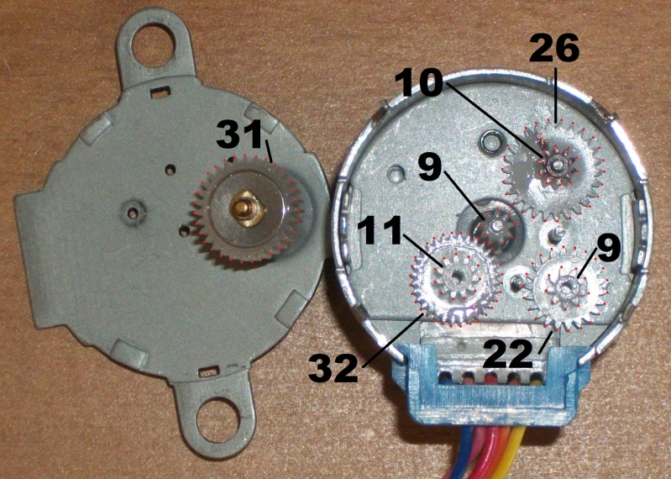

image from *forum.arduino.cc*

The gear ratio is:

$$\frac{31×32×26×22}{11×10×9×9}=63.68395$$

**Full-stepping**

* Internal motor: 32 steps per revolution
* Great reduction ratio: 1/63.68395, approximately 1/64
* So it takes $32×64=2048$ steps per revolution for the output shaft

**Half-stepping**

* Internal motor: 64 steps per revolution
* Great reduction ratio: 1/63.68395 ≈ 1/64
* So it takes $64×64=4096$ steps per revolution for the output shaft

Interfacing the stepper motor requires four pins. We select the following four pins to control the stepper motor: PB2, PB3, PB6, and PB7. The textbook provides a connection diagram for stepper motor Mabuchi #PF35T, which is very similar to the diagram below.

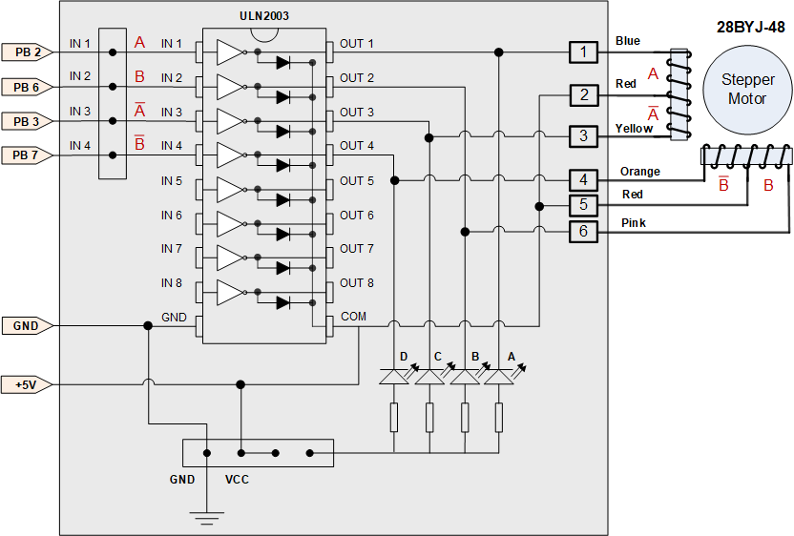

**Pre-Lab Questions**

1. Fill out the following timing diagrams for the GPIO outputs that create a full-stepping sequence and a half-stepping sequence.

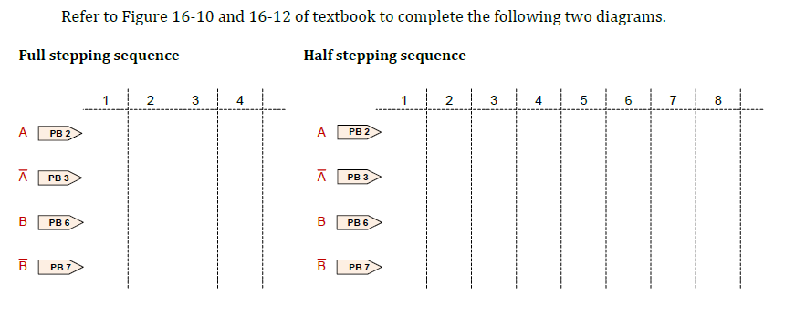

1. How would you change your code to vary the rotation speed of the stepper motor?
2. How would you reverse the rotation direction of the stepper motor?

**Participation and Contribution**

Please indicate the participation and contribution for each group member using the following table.

|  |  |
| --- | --- |
| Name | Participation and Contribution |
|  |  |
|  |  |